Lighting Models

📘 Definition
# Source: AI Source: Provided by: [Data Path: Persons Table -> ID Column: 1, Name_En Column: Motasem Essam] -> From: [ChatGPT] on [5/2/2026]
Lighting models are mathematical methods used in computer graphics to simulate how light interacts with objects. They help determine how bright, dark, shiny, or realistic a surface looks when light hits it.

💡 How lighting models work
# Source: AI Source: Provided by: [Data Path: Persons Table -> ID Column: 1, Name_En Column: Motasem Essam] -> From: [ChatGPT] on [5/2/2026]
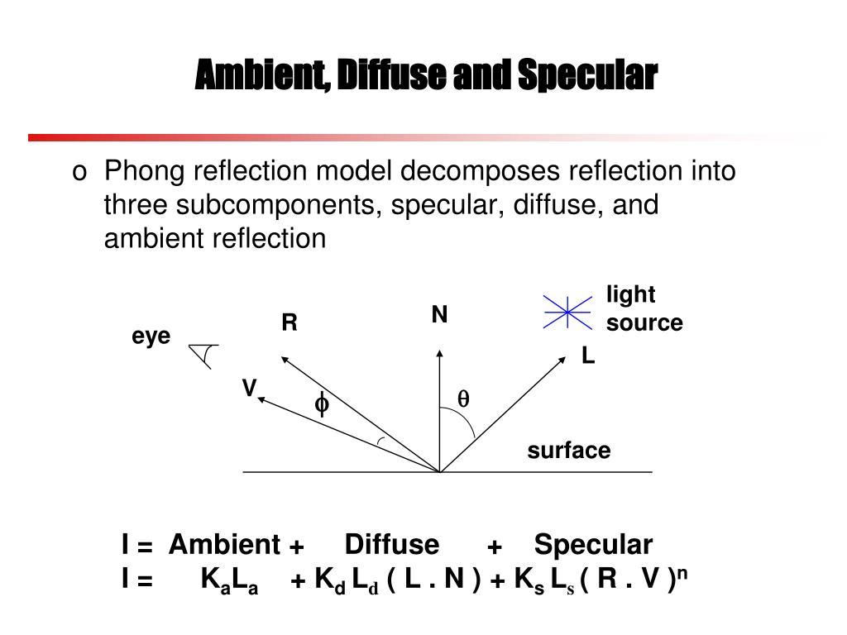
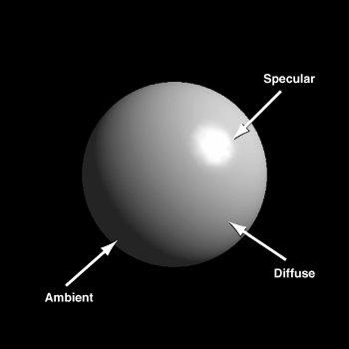
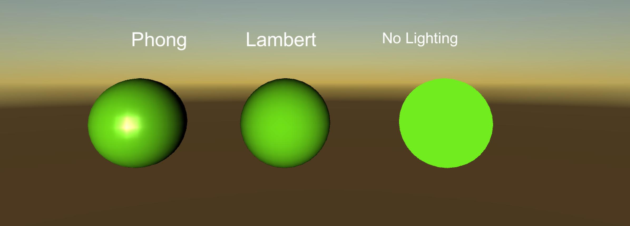
Lighting models calculate how light behaves using components like:
- 🌫️ Ambient light → general soft light everywhere
- 💡 Diffuse light → light scattered on rough surfaces
- ✨ Specular light → shiny highlights on smooth surfaces

🧠 Simple idea
# Source: AI Source: Provided by: [Data Path: Persons Table -> ID Column: 1, Name_En Column: Motasem Essam] -> From: [ChatGPT] on [5/2/2026]
Think of a ball under a lamp:
- One part is bright (diffuse + ambient)
- One shiny spot appears (specular highlight)
- The rest is darker (shadow area)
The lighting model is what calculates all of this.

🎮 Why lighting models are important
# Source: AI Source: Provided by: [Data Path: Persons Table -> ID Column: 1, Name_En Column: Motasem Essam] -> From: [ChatGPT] on [5/2/2026]
- 🎮 Make video games look realistic
- 🎬 Create lifelike movie CGI
- 🧑‍🎨 Help 3D artists control appearance of materials
- 🖥️ Simulate real-world lighting behavior

⚙️ Common lighting models
# Source: AI Source: Provided by: [Data Path: Persons Table -> ID Column: 1, Name_En Column: Motasem Essam] -> From: [ChatGPT] on [5/2/2026]
- 🌕 Lambert Model → simple diffuse lighting (matte look)
- ✨ Phong Model → adds shiny highlights (more realistic)
- 🌗 Blinn-Phong Model → improved specular reflection

🚀 In short:
# Source: AI Source: Provided by: [Data Path: Persons Table -> ID Column: 1, Name_En Column: Motasem Essam] -> From: [ChatGPT] on [5/2/2026]
Lighting models = rules and formulas that simulate how light interacts with objects to create realistic images in computer graphics.

